**CGH Project - Patient Safety Training**

**Vivian Choo Jia Xin, Ashton Lim Jing Jie, Shaun Sim Shi Jie**

**Supervisor: Mr Low Yin Jye**

***Abstract***

*This project aimed to design and create a user-friendly web portal to allow hospital staff to perform data admin tasks on a patient safety database. A web API was built to execute alterations to the database, and a web portal was created to consume the API and display data to the user. The portal has various functions including the paging, sorting and searching of data.*

1. **INTRODUCTION**

**1.1 Background**

A collaboration with Changi General Hospital (CGH) to develop a system where information would be retrieved from the database and display with extrapolated statistics. The project aims to create an easily usable way for the users to access the necessary information that they might need. The students will develop a system which is connected to the database via a web service and visualize the acquired data. The Web Portal will manage all data and report the Activity Logs accordingly.

**1.2 Objectives**

We are creating a website that processes data from a Virtual Reality (VR) Application made for Changi General Hospital (will be known as CGH from here on out) to access their doctors’ performance under the VR training.

The objective of this project is to collect, process and analyze data collected from the application that is used by CGH to produce a detailed data spreadsheet on a website so that CGH will be able to take over to be able to analyze and grade their doctors through the VR Training. The Website will have web services to fetch data from the servers and the VR application will directly provide the data to the servers, in a one-dimensional data transference from application to server to web service to website. This will then disallow direct communication from the website to the database and therefore providing CGH with better security for their database systems and preventing tampering of data.

1. **PROJECT DESCRIPTION**

Our aim is to design an admin website that will allow us to track data that has been input into the system and edit any existing data that requires creation, updating or deleting, e.g. Drug Data, Activity Data and Patient Data. Amongst other things, the user will be able to filter activity logs for entries belonging to a specific user.

The specific technical objectives were to create a web service that performs data functions on a database and a web portal that consumes the web service in a model-view-controller project. We created a dummy database for storage of data using Microsoft SQL Server Management Studio, developed the web services and web portal with ASP.NET Core.

**2.1 Project Development**

The project was mainly completed with Visual Studio 2019 as our base coding language we had used ASP.NET CORE

We worked separately as 3 different individuals with given tasks, from the start which was the creation of the database with its different tables to the creation of each website page with active functions.

We divided our tasks 3 ways and worked together to help each other with each task when we required assistance, for the most part we had to wait for everyone to finish their part of the project before we could continue as it was sequence work where we needed to complete the part before we could continue with the other parts.

In part, we could do our work respectively with help from time to time regarding some tasks and however we still manage to integrate our projects successfully with some timely setbacks occasionally due to lack of communication within the group. The process was mainly carried out with the idea of sequence working in mind, where we needed part 1,2 and 3 before we could continue to part 4, this caused us many setbacks as if one part was not completed, we could not continue.

Our project was separated into a few different parts

1. Database creation
2. CRUD Creation
3. WebAPI Creation
4. Web CSS Creation (Website Design)
5. Integration of parts

The way we handled the process was to divide the parts 3 ways to be completed, each of us would have receive a set number of things to complete to allow for progress for the group. The database consisted of 11 different tables which consisted of foreign keys, when we have completed our tables, we pass the generated tables onto the next person to work on the database and the process repeats.

As for the CRUD creations, we did it separately to improve efficiency as time constraints however we encountered a lot of the setbacks as we ran into many issues regarding the database constraints and other issues such as not being able to pull the correct data. When it came to the WebAPI Services, we had encountered problems when trying to use Data Transfer Object (DTO) which set us back with pulling data as we could not properly code our DTOs in, however we managed to finally work it out.

Web CSS took a while as it was very different from the coding languages that has used before where we could only hardcode the design in whereas before we could use in-app designers which made things easier for us. This part of the project did set us back for a while as we did not know how to do this new method of web design however, we eventually learnt with the help of the internet and we also learnt that we can use stuff that has been posted online in our work such as templates to ease our coding methods. We managed to come to a minimalist and simplistic design which looks pleasing to the eyes with the colors and an easy to use GUI. Our integration surprising was much easier as 2 of us had worked closely together when it came to initial coding and integrating the two part of the projects was easy due to the fact that we communicated a lot during the projects, however our third member was more of the unsocial one, completing most of the work solo while also using a different type of coding, however we still managed to integrate our projects in the end although we still needed to choose a single type of coding design. Overall, our process of the project was very rocky as we had a rough start when we had a lot of miscommunications amongst our group as we could not work well but we eventually pulled through and managed to deliver.

**2.2 Process Description**

Our website starts off with a login, with pre-existing users in the database to allow for access into the website.

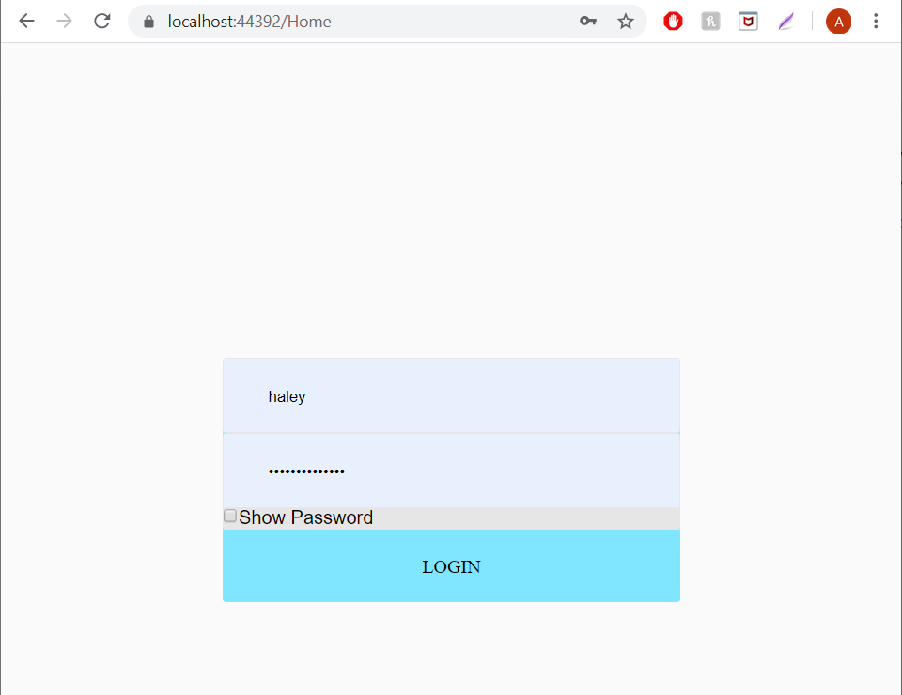

The login page allows for validation and showing of password

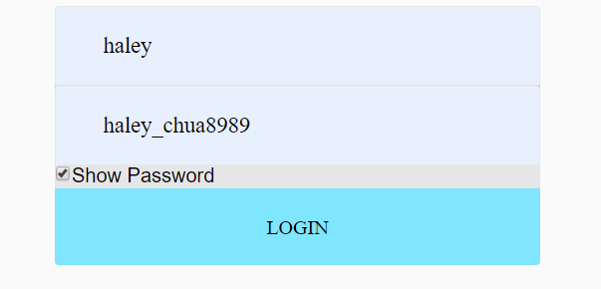4

After logging in, it brings the user to the home page with the side bar that allows users to select the tables and see the respective data that is called with WebServices uses WebApi from the respective tables.

From the main home page, you can also see the CSS done for the website.

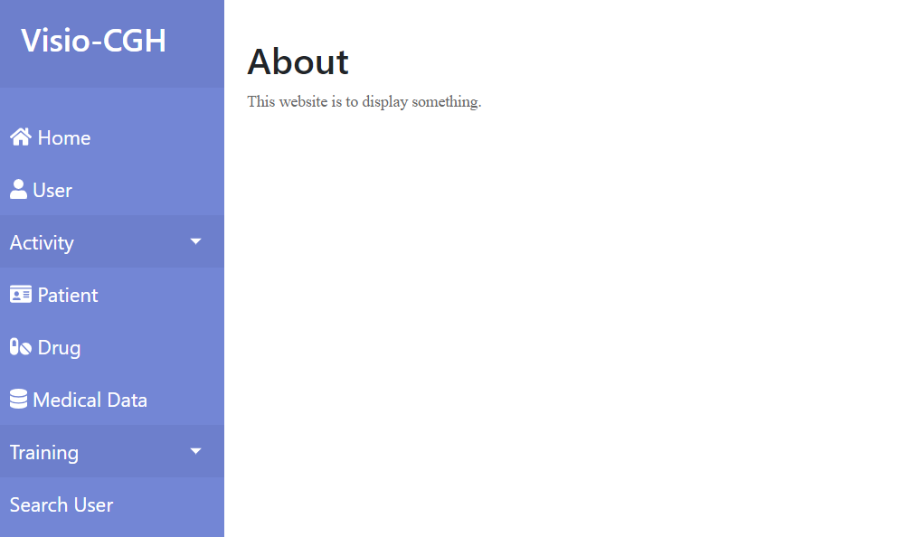

When the table is selected, user will be able to read all data retrieved, some tables are able to create, update and delete entries. This is done using WebServices, WebAPIs and CRUD services,

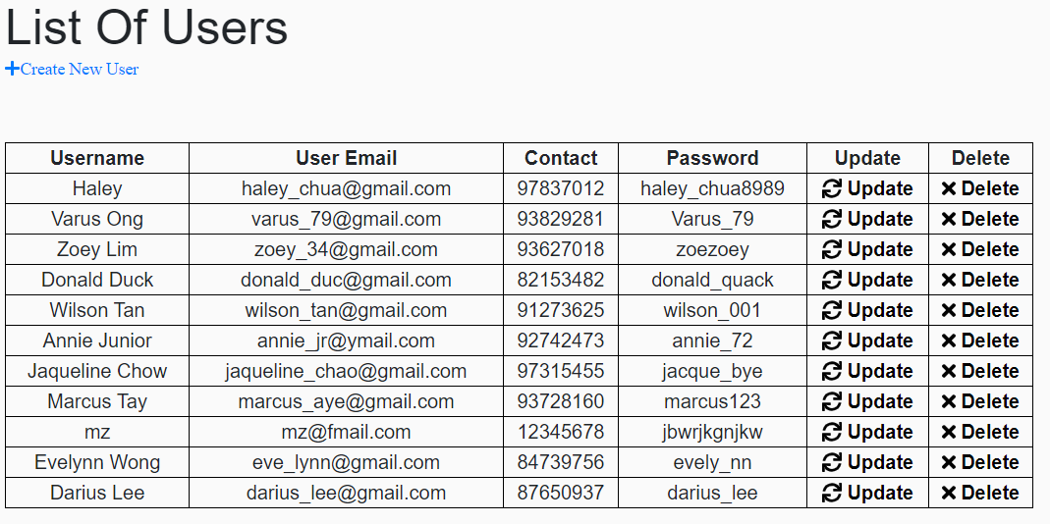

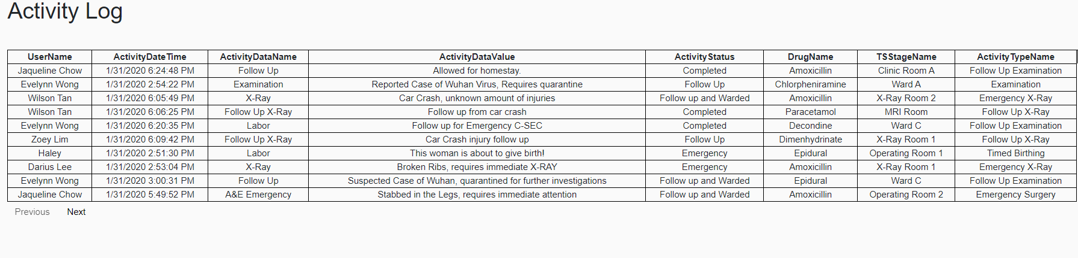

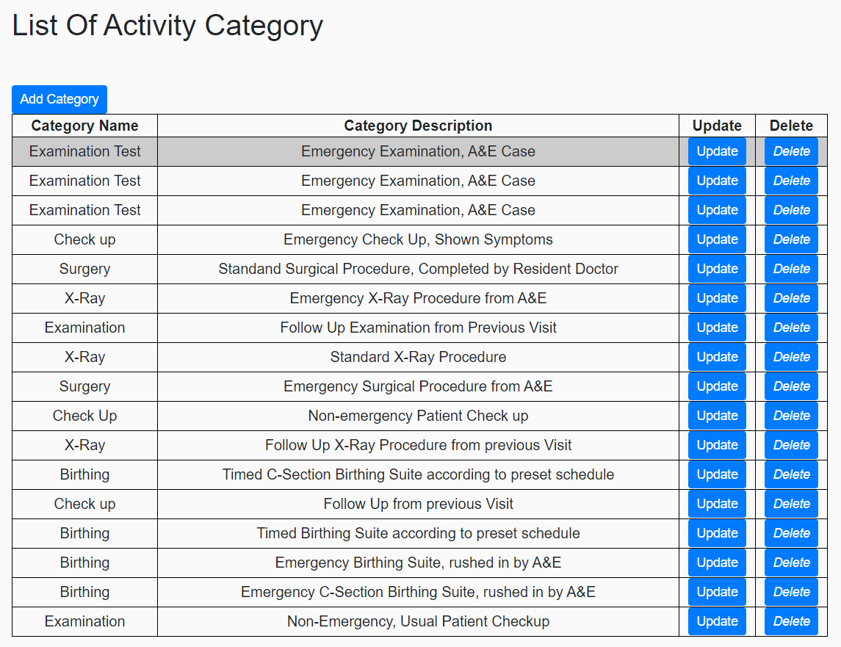

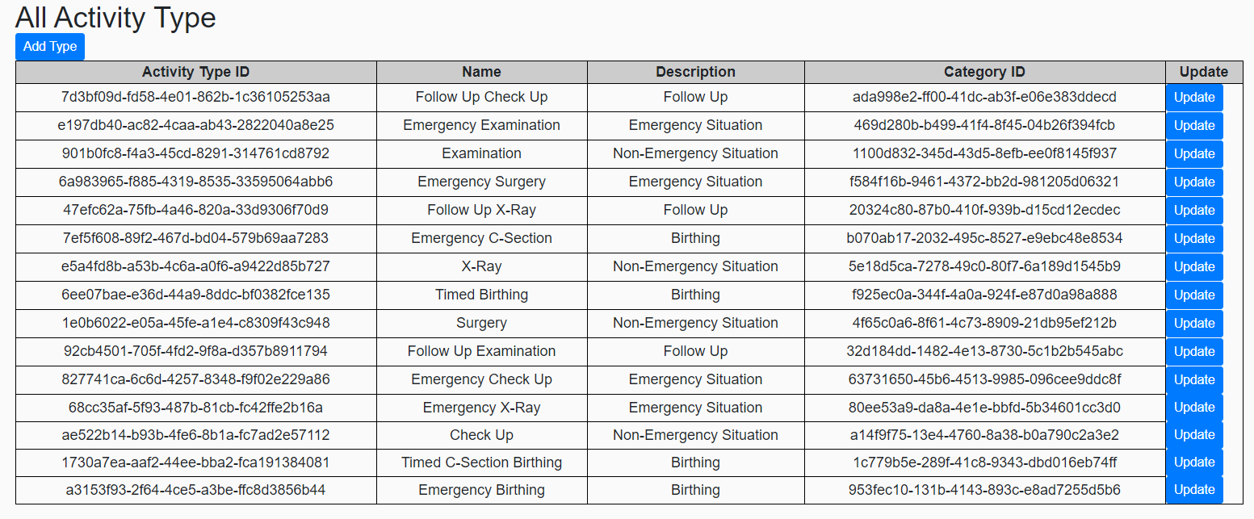

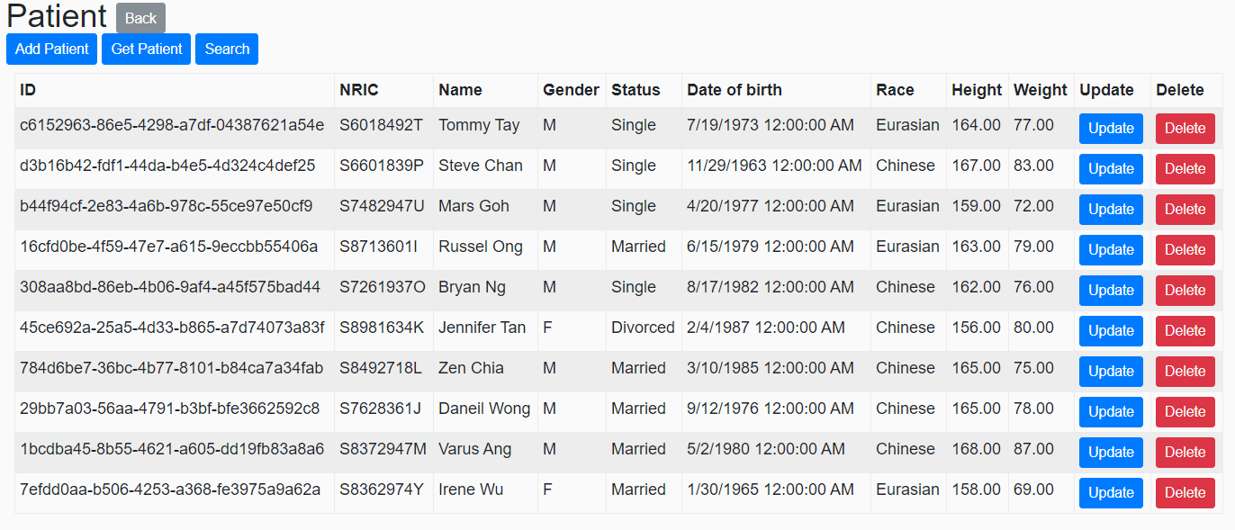

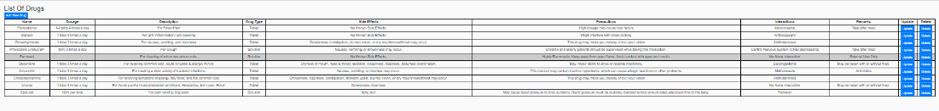

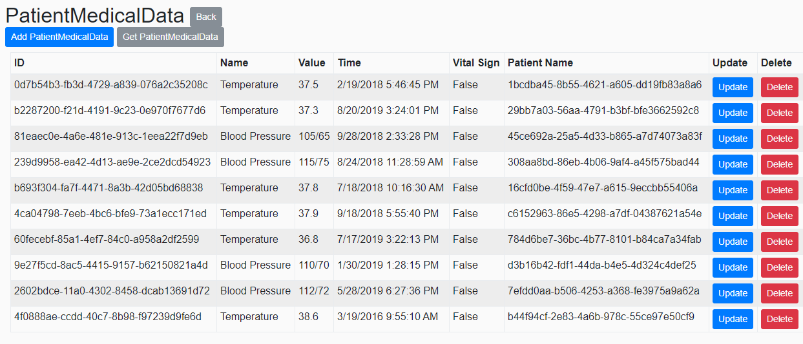

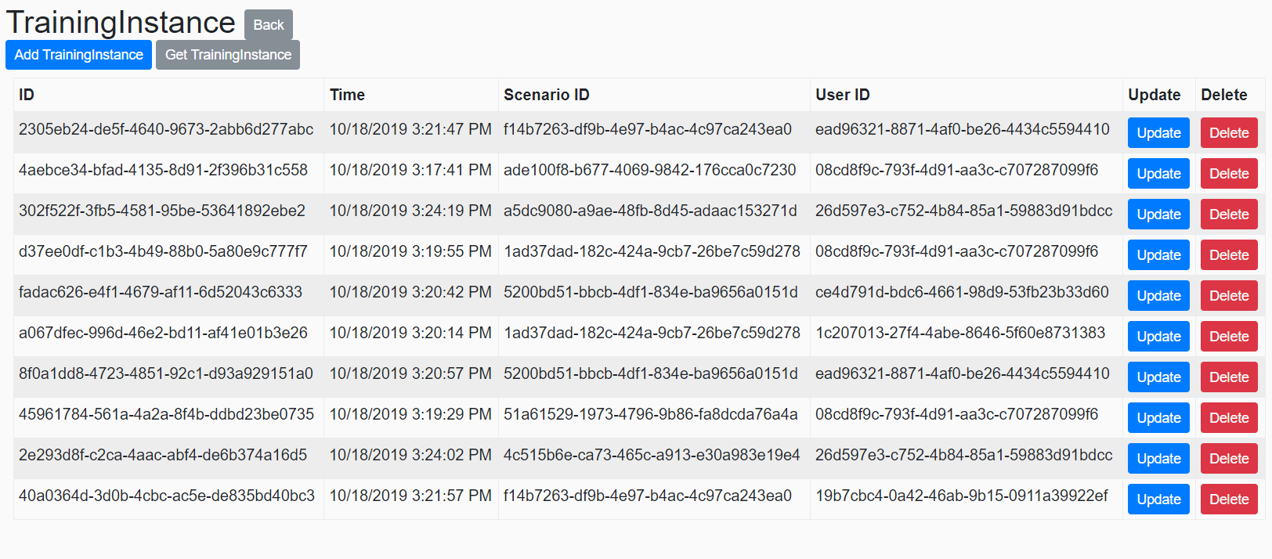

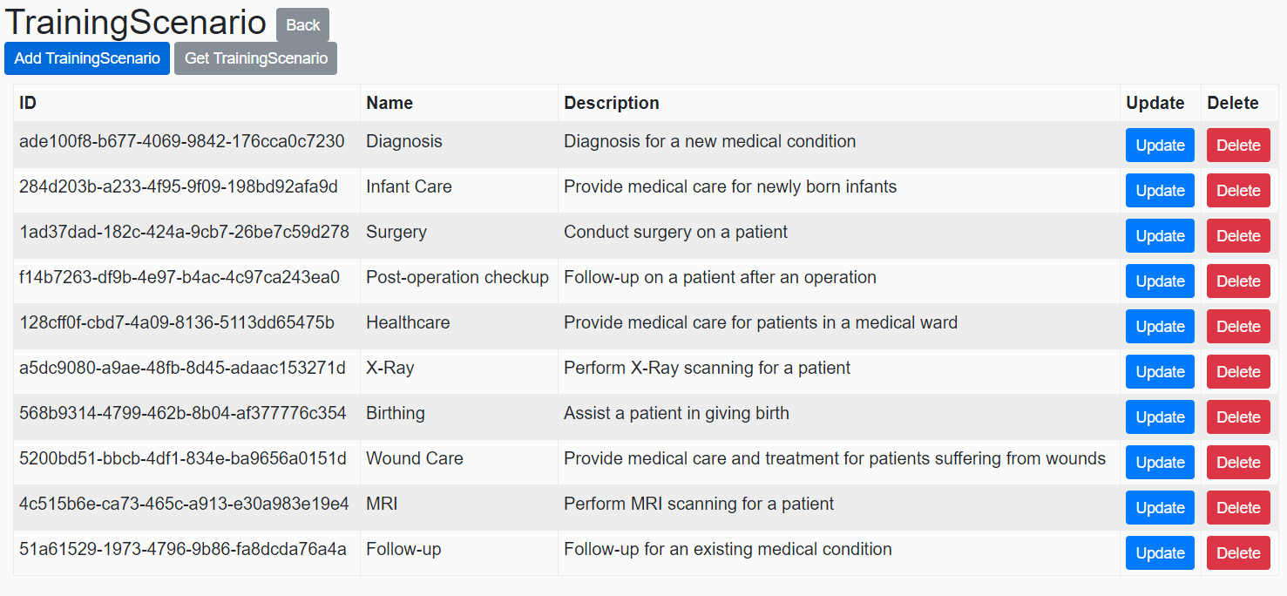

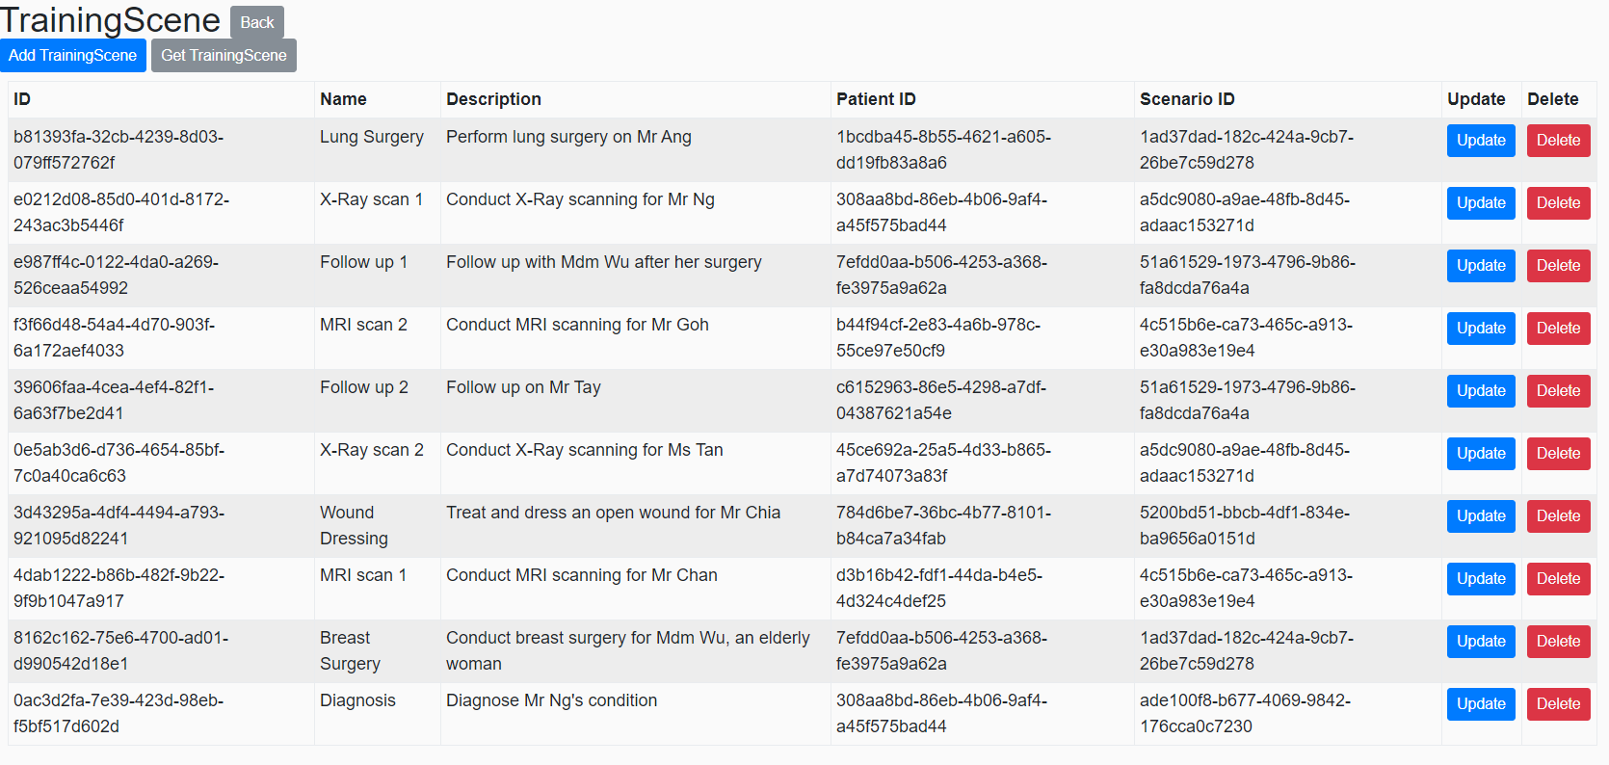

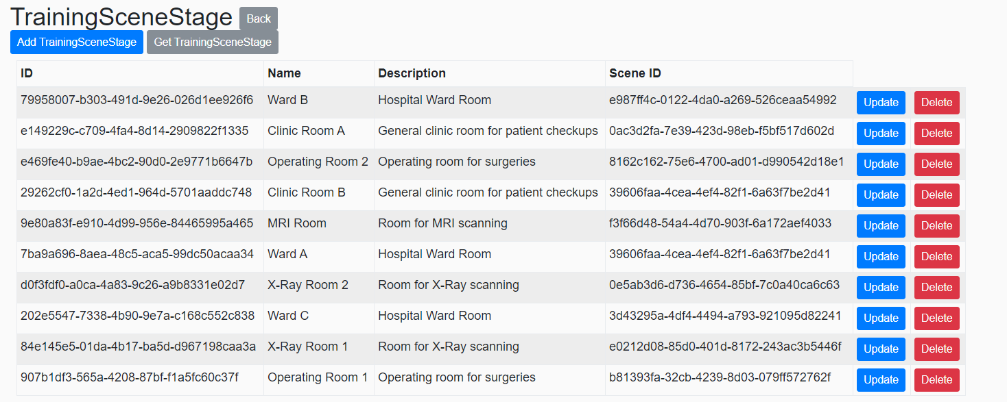

The images provided are the tables that we have done and have data modified.

The overall process will allow users to create, read, update and delete data through the website, which is using WebServices that calls the generated WebAPIs to do any modification to the data in the database.

**Acknowledgements**

The authors would like to thank Mr Low Yin Jye (Major Project Supervisor) for his patience and help.

**Works cited**

**Other Sources**